**LAPORAN**

Program Iterasi



**Steven Cuaca 20165520019**

**Jevon Adriel 20165520024**

**Nicholas Suryawan 20165520028**

**PROGRAM STUDI TEKNIK INFORMATIKA**

**FAKULTAS SAINS, TEKNOLOGI, TEKNIK, DAN MATEMATIKA**

**TANGERANG**

**2018**

**Soal:**

Quadratic Equation: X3 – 3X – 2 = 0

Root Equation:

1. X = (X3 – 1) / 3
2. X = (3X + 1) / X2
3. X = 1 / (X2 – 3)

**Solution:**

Dengan menggunakan program:

C++

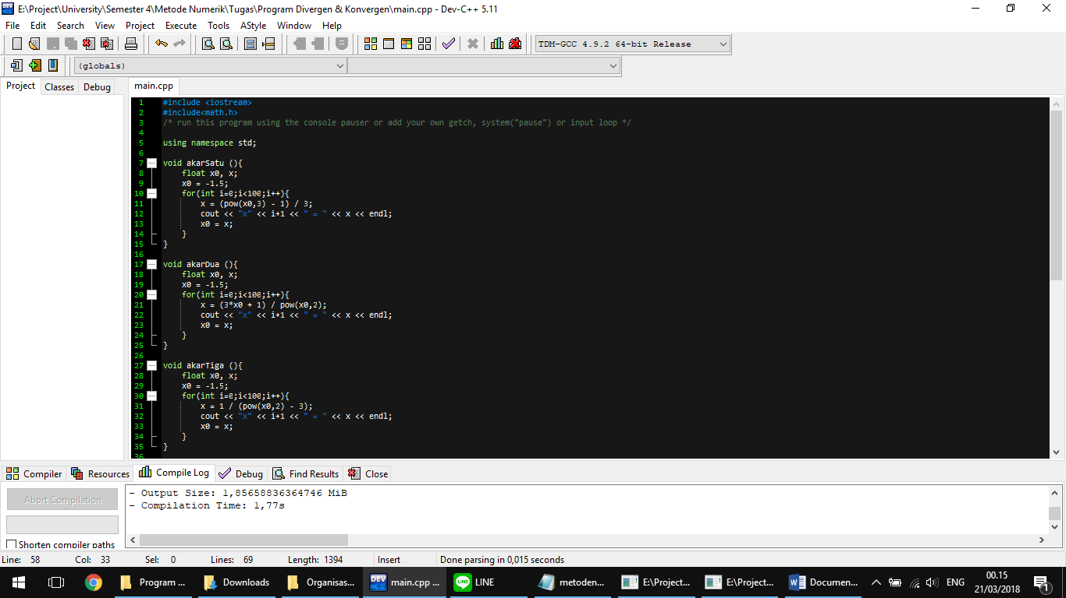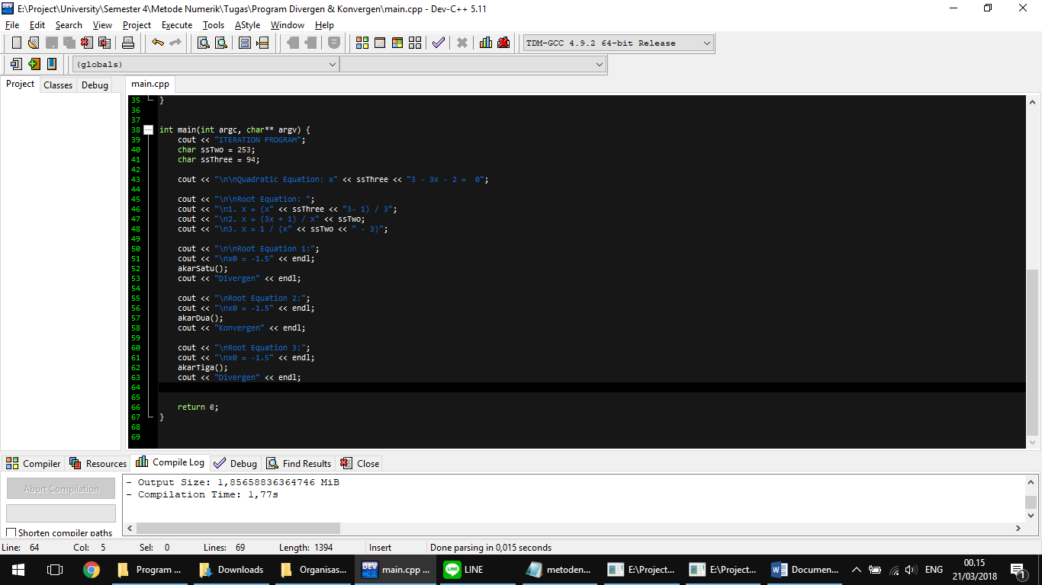

Output:

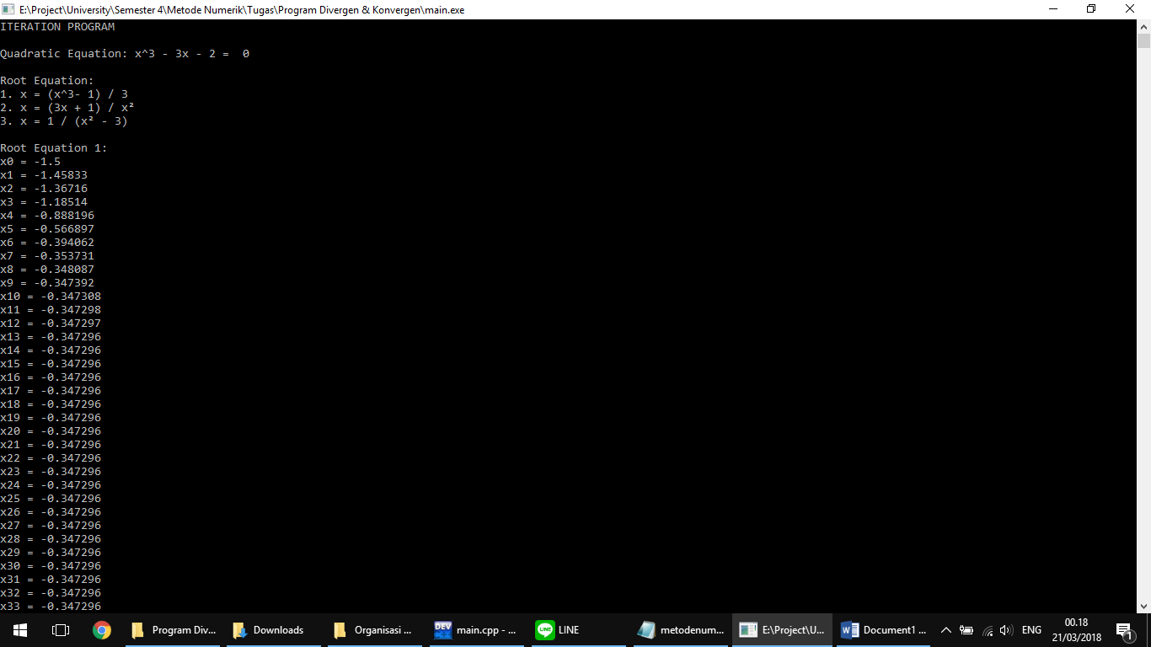

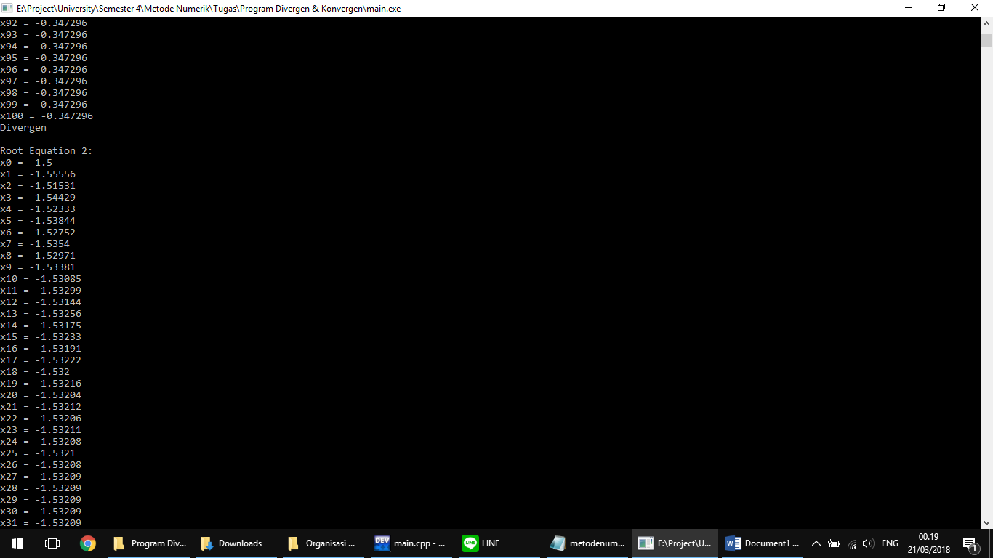

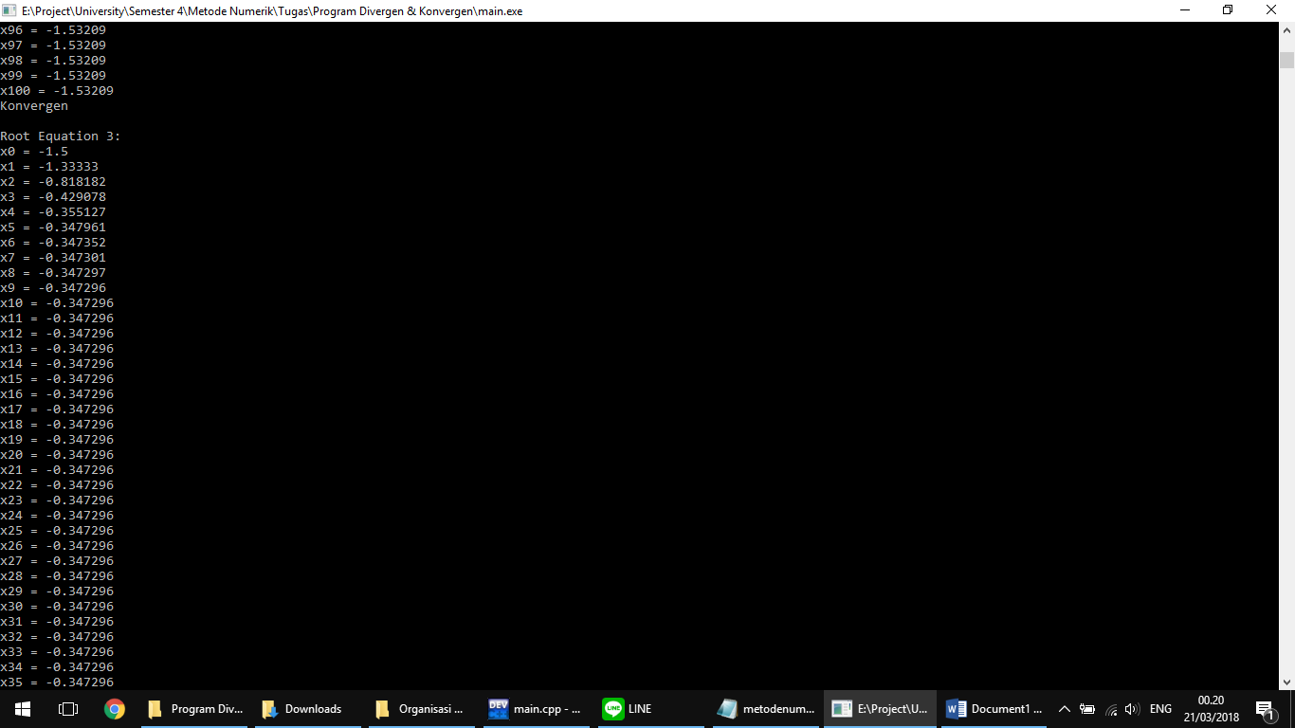

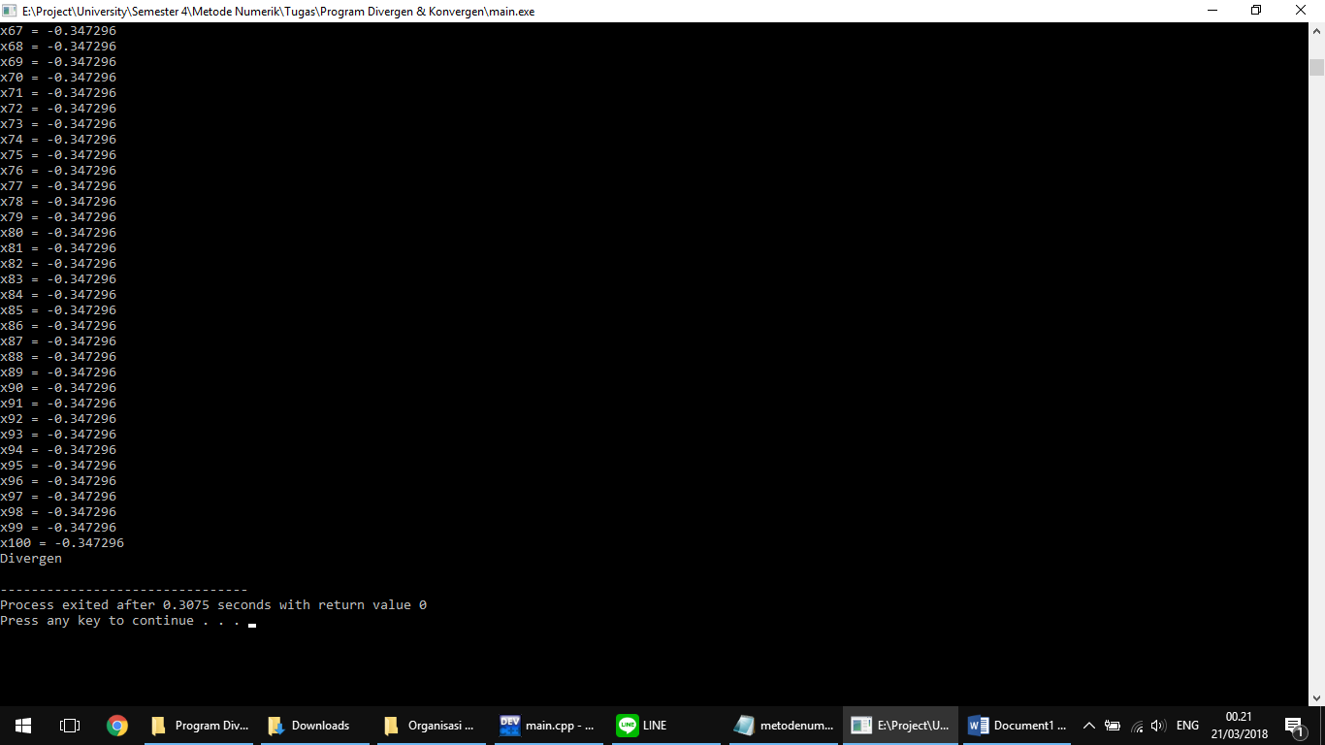

Link for Source Code: https://goo.gl/Q3V7do